REGISTRATION FORM

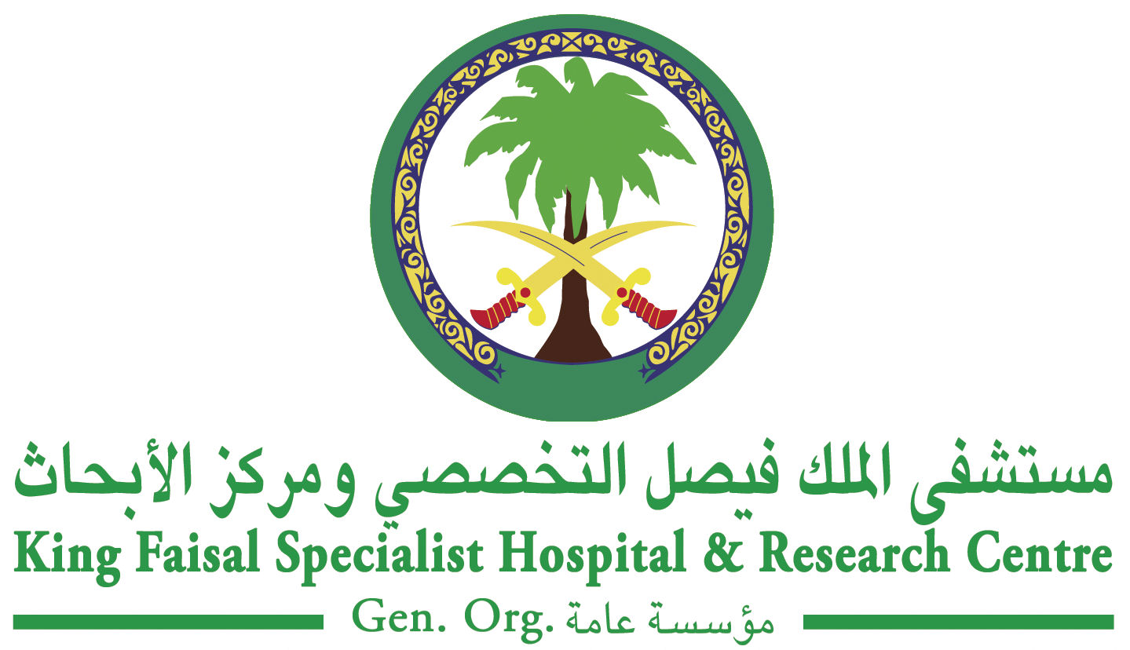
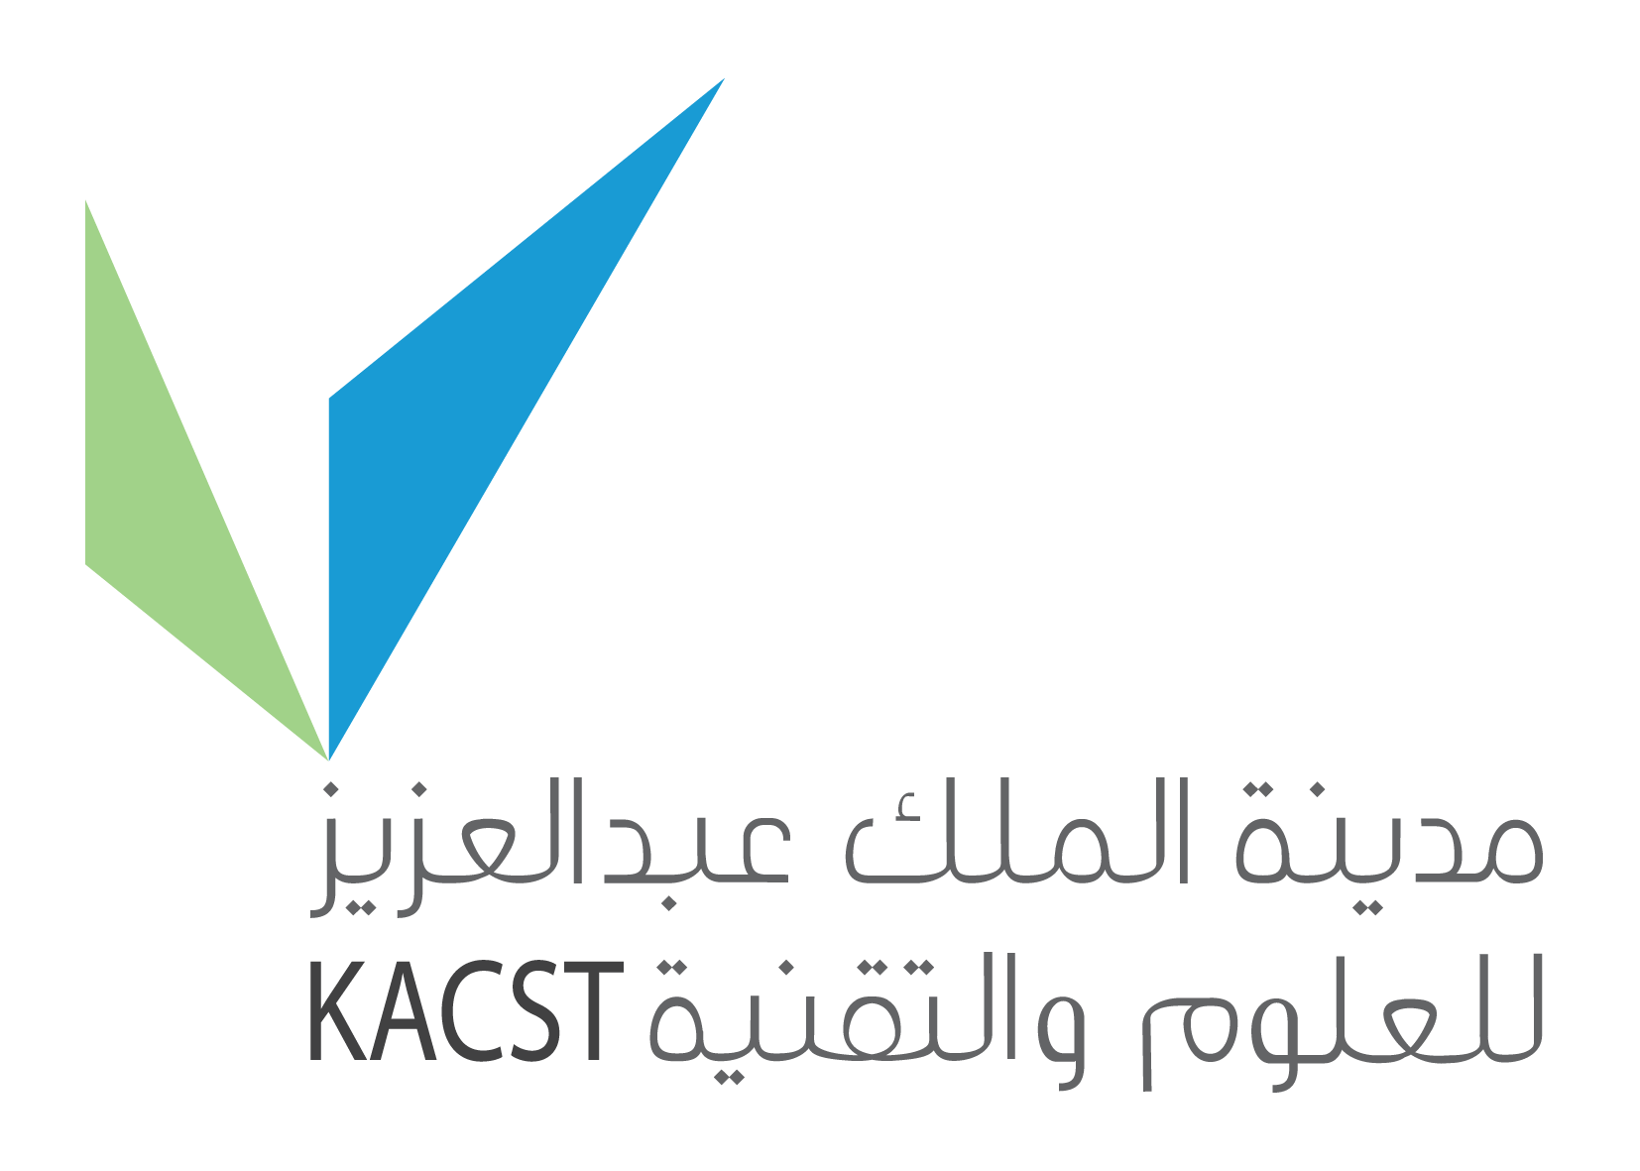

IAEA REGIONAL TRAINING COURSE ON RADIOTHERAPY TECHNIQUES
WITH EMPHASIS ON IMAGING & TREATMENT PLANNING

VENUE: King Faisal Specialist Hospital and Research Centre, Riyadh, Kingdom of Saudi Arabia
11 - 15 Dhu Al- Qada 1432 (09 - 13 October 2011)

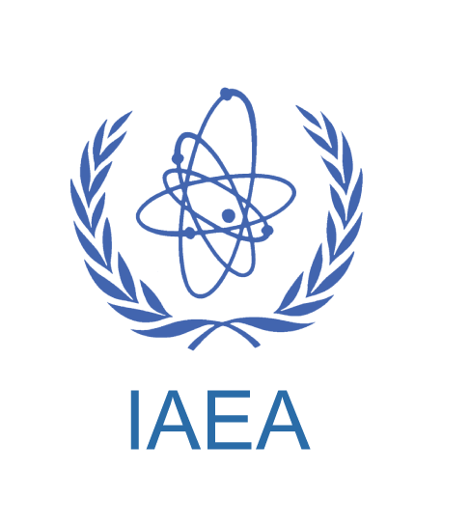

NOTE: Please print clearly and ensure that you use the correct spelling of your name as you wish it to be printed on the certificate. Use TAB to move between fields.

First  Name: |  |  | Middle Name: |  | Family Name:
Title: | Prof. Dr. Mr. Mrs. Miss Other |  |  |  | Gender: | Male Female
Profession:
Specialty & Qualifications:
Institution Name:
Mailing Address: | City: |  |  |  | Telephone No:
Mailing Address: | Postal Code: |  |  |  | Fax No:
Mailing Address: | Country: |  |  |  | Mobile No:
 |  |  |  |  | Email:

Send completed registration form to:

Ms. Josephine Veridiano
Biomedical Physics Department, Research Centre, MBC#03
King Faisal Specialist Hospital & Research Centre
P.O. Box 3354, Riyadh 11211, Kingdom of Saudi Arabia
Tel: +966 (1) 442-7879
Fax: +966 (1) 442-4777
Email: josfin@kfshrc.edu.sa

For more information, please visit our website www.radmed.org

